**DAY-11 OUTPUT:**

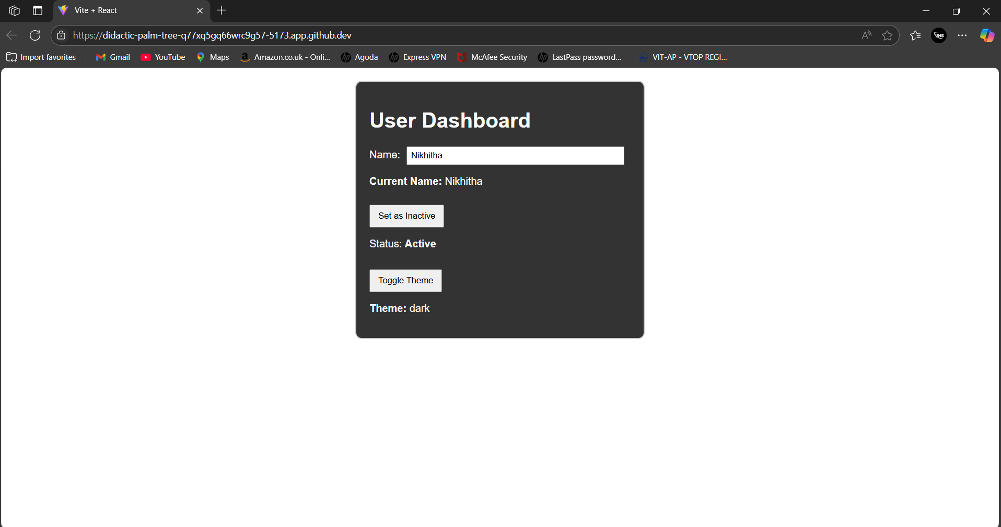

WE CAN CHANGE THE TOGGLE THEME ,STATUS OF CURRENT USER,

IF THE CURRENT USER IS INACTIVE; IT DISPLAYS A MESSAGE AS SHOWN BELOW:

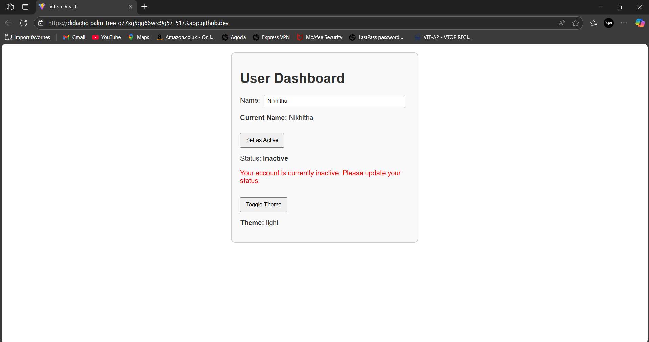

HANDLING USER INPUT FOR NAME CHANGE:

